HIGH LIFE HIGHLAND  REPORT TO BOARD OF DIRECTORS  23 April 2014 | AGENDA ITEM REPORT No HLH /14

ANNUAL Health and Safety Report - Report by Chief Executive

Summary

An important element of the Governance structure relating to the company’s Health and Safety performance is the Health and Safety Annual Report.

This report informs Directors about the performance of High Life Highland in terms of health and safety management.

It is recommended that Directors:-

- note the low number and low severity of incidents over the period reflecting continuing good practice across the company;
- note that the Health and Safety Strategic Group continues to meet quarterly to review Health and Safety performance; and
- agree to the change of layout proposed in paragraph 2.3.

1. | Business Plan Contribution
1.1 | This report supports the highlighted Business Outcomes from the High Life Highland (HLH) Business Plan:  - A positive company image  - A growing company  - Delivery of the contract with THC  - Increased awareness of HLH products and services  - Increased customer satisfaction  - Increased financial sustainability  - Increased internal collaboration  - Increased staff satisfaction  - Safety & environmental compliance
2. | Background
2.1 | The terms of the HLH Health and Safety Policy Statement requires annual and exception reporting to the HLH Board on health and safety performance
2.2 | At the meeting on the 6 December 2012 Directors remitted the content of the annual health and safety report to the Health and Safety Strategic Group.
2.3 | Taking on board comments made by Directors at the time, the Health and Safety Group agreed that the Annual Report to the HLH Board should consist of:  - details of all RIDDOR reported accidents and a summary of the follow up internal investigation and actions resulting (Appendix A);
- a graph or table of all accidents and incidents by quarter, and compared to the previous year to staff and contractors by:
- HLH section e.g. libraries, leisure centres (Appendix B tables 1- 10)
- Nature of accident i.e. accident with injury, accident without injury, act of violence, other (Appendix B tables 11-13)
- Type of accident/ incident e.g. fracture, bruise, burn etc. (Appendix B tables 14-16)

- A graph or table of all accidents and incidents by quarter, and compared to the previous year to users by:

- HLH section e.g. libraries, leisure centres (Appendix C table 1)
- Nature of accident i.e. accident with injury, accident without injury, act of violence, other (Appendix C table 2)
- Type of accident/ incident e.g. fracture, bruise, burn etc.(Appendix C table 3)

- PIs:
- number of accidents and incidents to staff against numbers of FTE staff (Appendix D):
- number of accidents and incidents to users against total number of users (Appendix D):

2.4 | Providing the information in the appendices on a quarterly basis as listed above, while comprehensive, makes annual at a glance comparisons difficult. It is recommended that the Board retains the same suite of information in its annual report, but uses annual figures instead of quarterly. The look of the new suggestion will be available in the Chief Executive’s presentation. The Health and Safety Strategic Group (which has Board members attending) is reviewing the same information on a quarterly basis.
3. | Health and Safety Performance
3.1 | Performance statistics and graphs for the period April 2012 to March 2014 are included in the appendices. There are no trends which suggest that any company wide actions are required.
3.2 | There were four accidents reported under the RIDDOR regulations and where appropriate, specific action has been taken to avoid recurrence.
3.3 | Given the size of the HLH operation and the number of visits to HLH facilities (almost four million per year), there have been a very small number of incidents, reflecting good practice in our facilities. Good progress has been made in terms of reviewing all policies and procedures, and the external audit this year will focus on how well sites and staff are implementing them.
4. | Risk Implications
4.1 | Resource Implications – there are no additional resource implications arising from this report.
4.2 | Legal Implications - there are no additional legal implications arising from this report.
4.3 | Risk Implications – there are no new risks which require to be added to the risk register arising from this report.

Recommendation

It is recommended that Directors:-

- note the low number and low severity of incidents over the period reflecting continuing good practice across the company;
- note that the Health and Safety Strategic Group continues to meet quarterly to review Health and Safety performance; and
- agree to the change of layout proposed in paragraph 2.3.

Signature:

Designation: Chief Executive

Date: 9 April 2014

Appendix A
All RIDDOR Notified Accidents/Incidents – Summary

 | 2013-14
Service Area | Q1 Apr-Jun | Q2 Jul-Sep | Q3 Oct-Dec | Q3 Jan-Mar
Adult Learning
Archives
Arts
Leisure Facilities |  | 1 | 1 | 1
Libraries
Museums |  | 1
Outdoor Education
Sport
Youth
Management & Administration
GRAND TOTAL | 0 | 2 | 1 | 1

All RIDDOR Notified Accidents/Incidents – Details Q1 – Q4 2013-14
INCIDENT 1
DESCRIPTION: Child fell in family changing room and cut forehead on floor tiles. This resulted in cut and bruised forehead.
RECOMMENDATIONS: Staff member checked reports for trends/similar accidents. None found so no improvements required.
Leisure Facilities- - - - - Lochaber Leisure Centre
INCIDENT 2
DESCRIPTION: Customer had gone to the ladies toilet with his aunt. When leaving, customer thought he would help to open the door and when the aunt closed the door did not realise child’s finger was in the door frame.
RECOMMENDATIONS: Please note this incident was not reported at the time. Incident was reported to staff on 19/8/13. Door finger guards have subsequently been installed.
Museums- - - - - - - Inverness Museum & Art Gallery
INCIDENT 3
DESCRIPTION: Customer stepping up into minibus and lost her balance. Saved from falling by others there but grazed her leg and only noticed once in minibus. Ambulance called and took customer to hospital.
RECOMMENDATIONS: Step be supplied to help elderly customers getting in and out of minibus
Leisure Facilities- - - - - - - Other
INCIDENT 4
DESCRIPTION: Whilst playing football, customer was pushed into wall and then fell over onto floor.
RECOMMENDATIONS: N/A
Leisure Facilities- - - - - - - Hilton Community Centre

Appendix B, Tables 1-10

Accidents and incidents by quarter compared to the previous year for staff, volunteers and contractors by HLH section

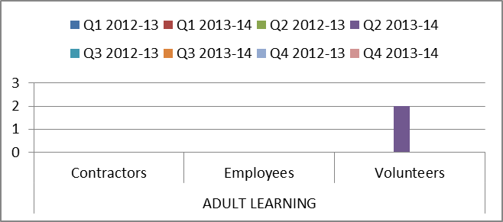

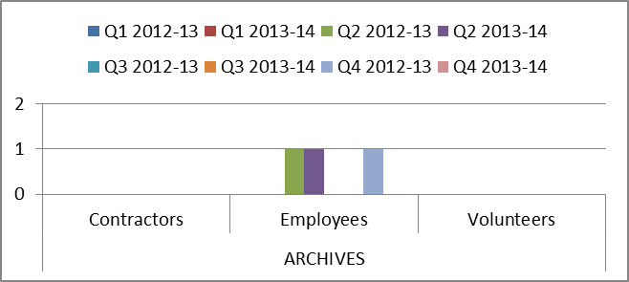

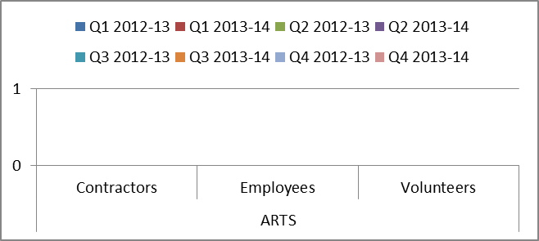

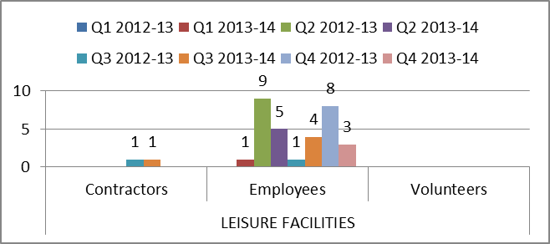

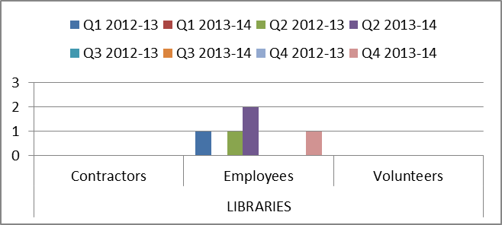

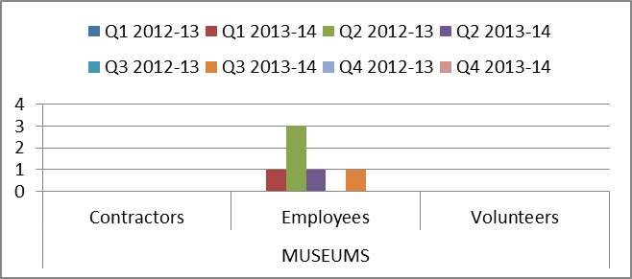

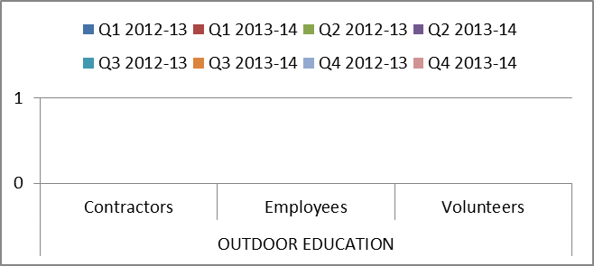

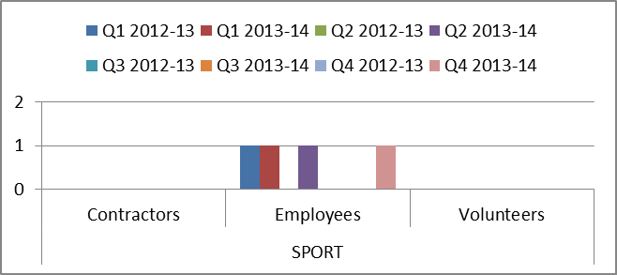

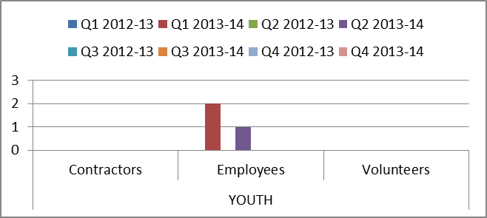

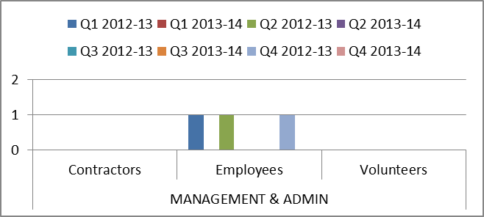

Appendix B, Tables 11-13

Accidents and incidents by quarter compared to the previous year for staff, volunteers and contractors by nature of accident

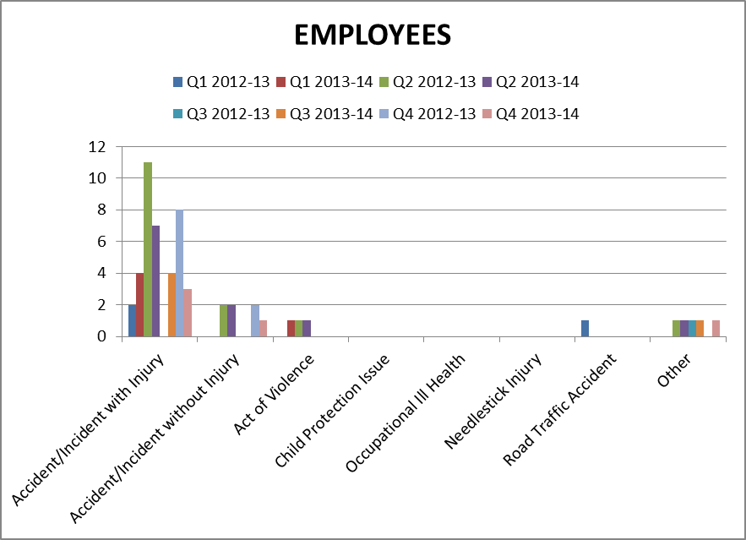

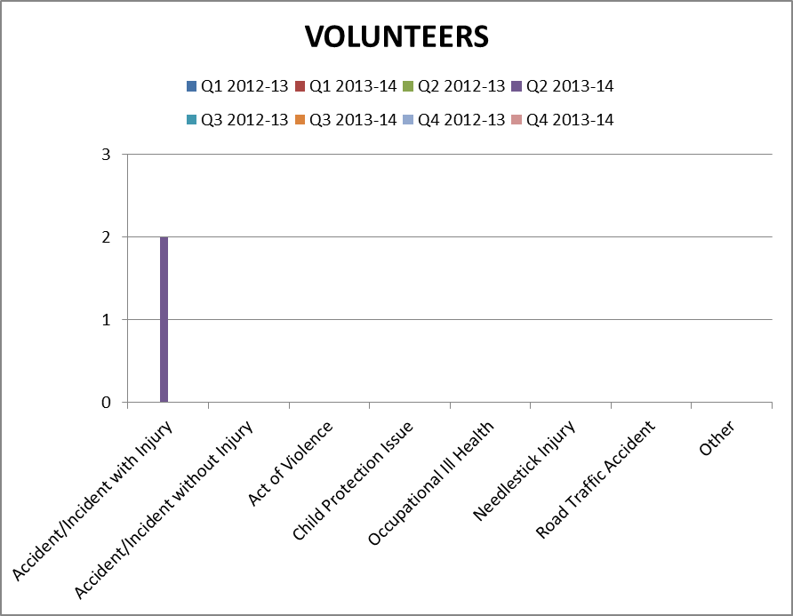
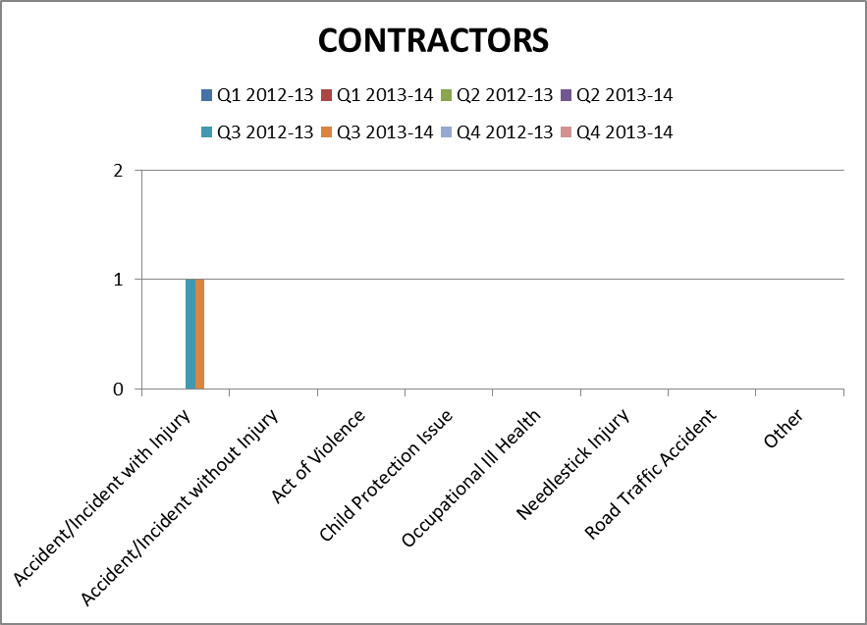

Appendix B, Table 14 - 16
Accidents and incidents by quarter compared to the previous year to staff, volunteers and contractors by type of accident/ incident

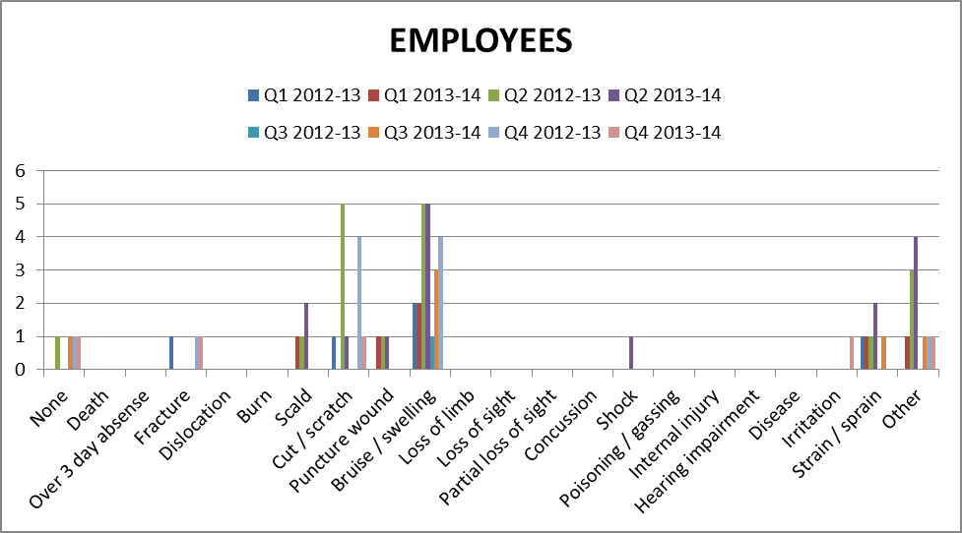

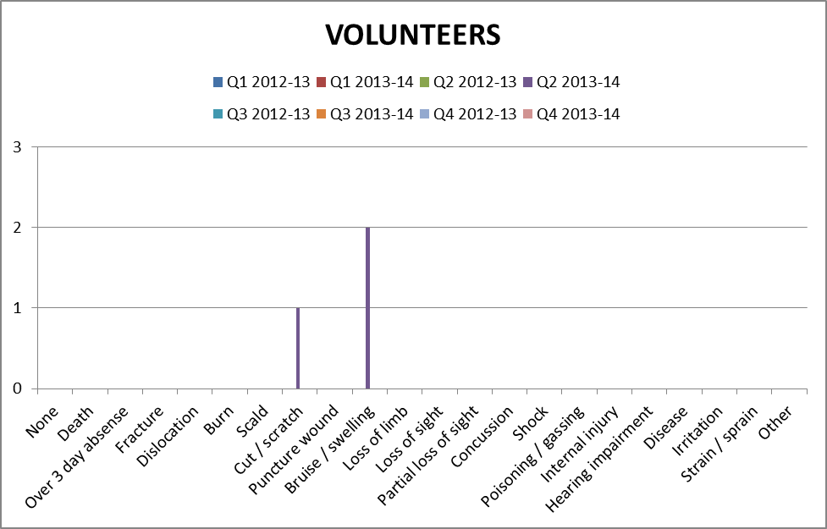

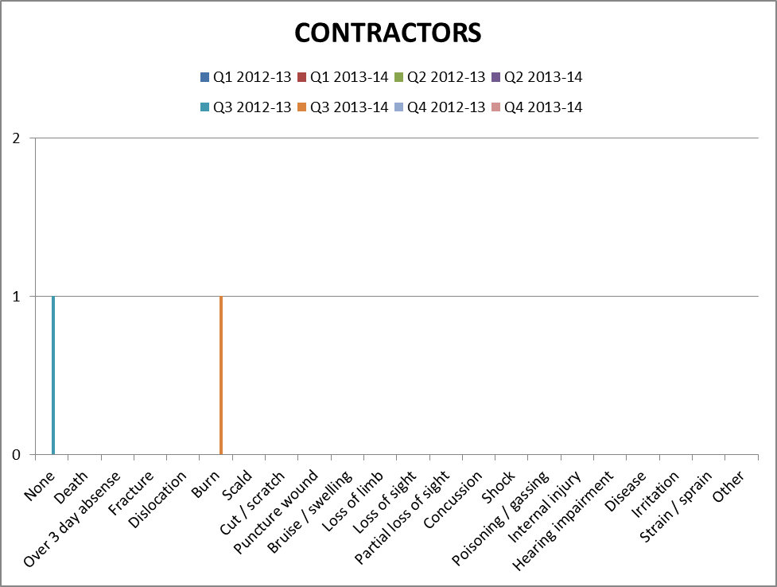

Appendix C, Table 1

Accidents and incidents by quarter compared to the previous year for users by HLH section

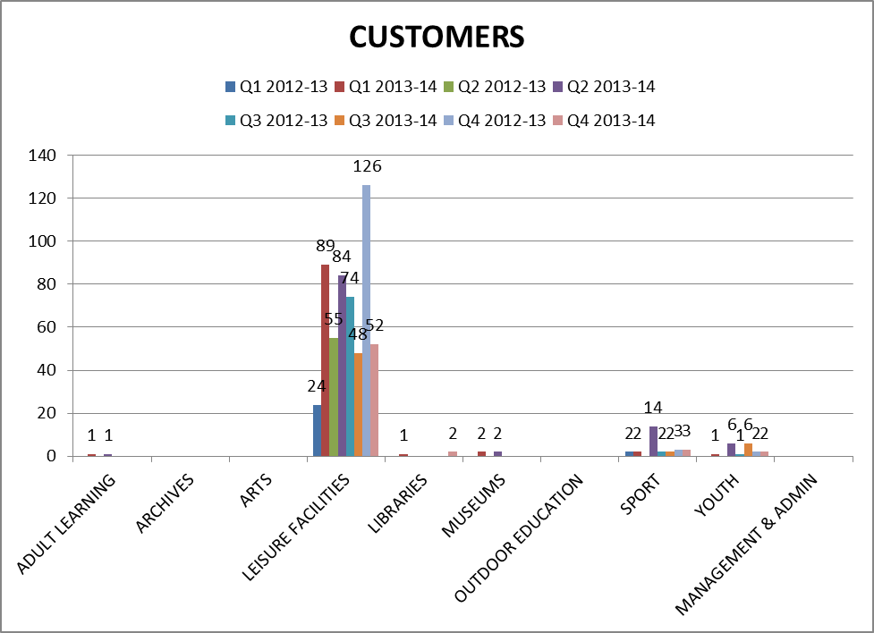

Appendix C, Table 2

Accidents and incidents by quarter compared to the previous year for users by nature of accident

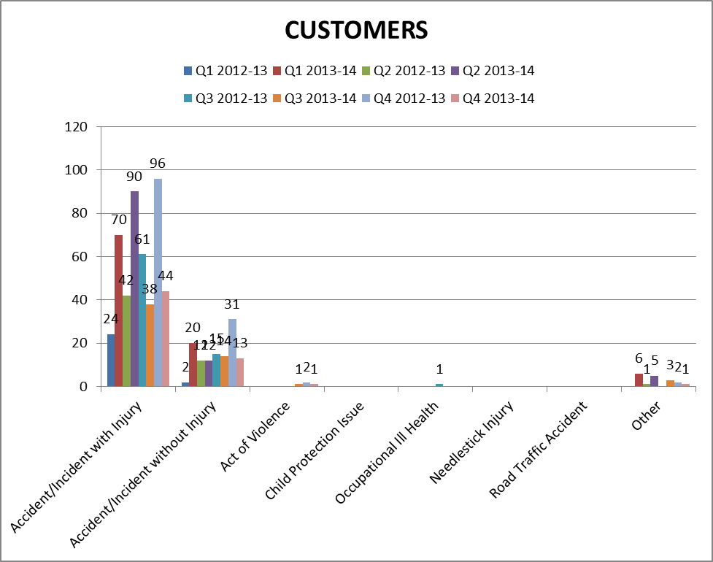

Appendix C, Table 3

Accidents and incidents by quarter compared to the previous year to users by type of accident/ incident

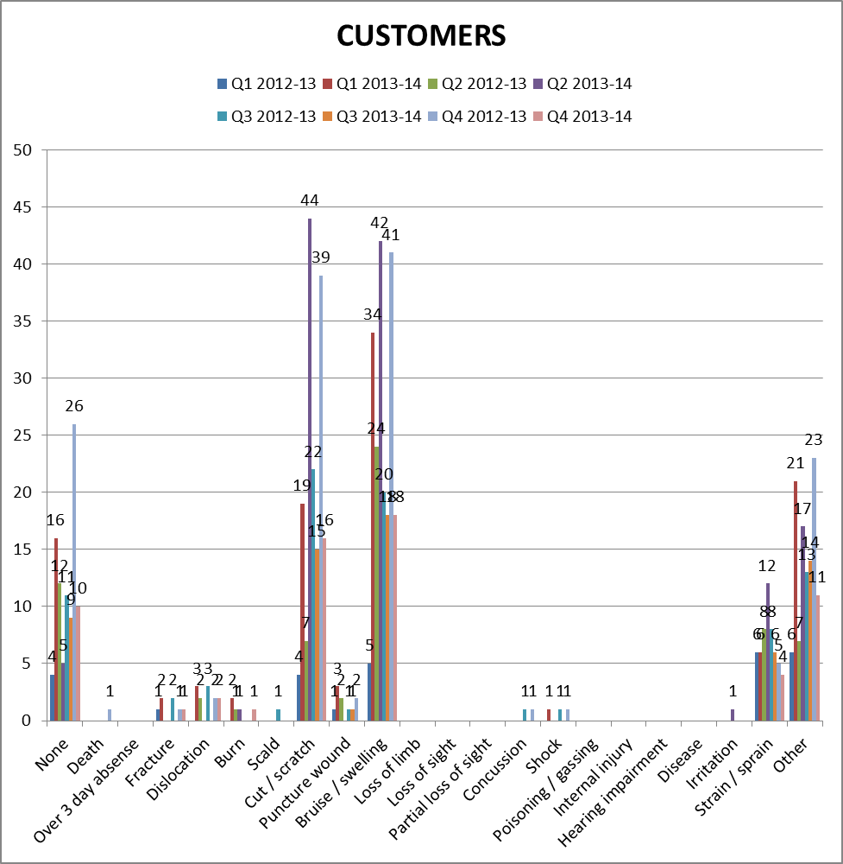
Appendix D
PERFORMANCE INDICATORS 2013-14
- Number of Accidents/Incidents to Staff (Employees, Contractors & Volunteers) Against Total Number of FTE Staff
 | FTE Staff | Accidents/Incidents | %
Q1 2013-14 | 489.04 | 5 | 1.0
Q2 2013-14 | 499.586 | 13 | 2.6
Q3 2013-14 | 501.286 | 6 | 1.2
Q4 2013-14 | 502.136 | 5 | 1.0

- Number of Accidents/Incidents to Users (Customers) Against Total Number of Users
 | Users | Accidents/Incidents | %
Q1 2013-14 | 1,001,770 | 96 | 0.010
Q2 2013-14 | 923,953 | 107 | 0.012
Q3 2013-14 | 927,840 | 56 | 0.006
Q4 2013-14 | 1,127,413 | 58 | 0.005

Appendix E

