HIGH LIFE HIGHLAND  REPORT TO BOARD OF DIRECTORS  21 August 2014 | AGENDA ITEM REPORT No HLH /14

Quarterly Performance Report - Report by Chief Executive

Summary

The purpose of this report is to present performance information for the period April to June 2014.

It is recommended Directors:-

- comment on the report and agree that the overall health check on the company for the period is assessed as green;
- note the performance of the company against its business plan objectives;
- note that Leisure Facilities and Libraries compare well with the national figures for cost per attendance and that this is an indication that HLH services are providing good value for money; and
- note that the wide variation in cost per attendance for Museums reflects the widely varying differences in museums across Scotland and agree that because of this any future benchmarking comparisons focus only on Libraries and Leisure Facilities.

1. | Business Plan Contribution
1.1 | This report supports all the Business Outcomes from the High Life Highland (HLH) Business Plan and will provide an overview of the Company:  1. A positive company image  2. A growing company  3. Delivery of the contract with THC  4. Increased awareness of our products and services  5. Increased customer satisfaction  6. Increased financial sustainability  7. Increased internal collaboration  8. Increased staff satisfaction  9. Safety & environmental compliance
2. | Background
2.1 | At the September 2012 meeting Directors agreed that its high level performance monitoring should focus on 10 business critical areas.
3. | Summary of performance
3.1 | Seven of the ten indicators have been rated as being on target with one being amber. Two of them have not been rated as they are annual or six-monthly indicators. Appendix A contains the summary of performance against the performance indicators. Appendix B contains further information on performance indicator vii, leisure centre customer numbers.
4. | Value for Money – Assessment from information contained in The Local Government Benchmarking Framework: National Benchmarking Overview Report 2014
4.1 | Directors have expressed interest in benchmarking comparisons. It is possible to make approximate value for money assessments for leisure facilities; libraries; and to a lesser extent museums, using the “Local Government Benchmarking Framework: National Benchmarking Overview Report 2014” which was published in March 2014. The figures should be treated as approximations/indicators of performance only because of the variations between services, methods of providing buildings and, therefore attributing costs (e.g. shared use with schools arrangements) etc.
4.2 | The table below shows the cost per attendance for Scotland and HLH in 2012/13.
  Area of Work | Scottish cost per visit range (£) | Scottish average cost per visit (£) | HLH cost per visit (£)
  Libraries | 2.00-6.42 | 3.31 | 2.00
  Museums | 0.34-18.92 | 3.94 | 4.73
  Leisure Facilities | 1.82-9.92 | 3.82 | 2.02
4.3 | Libraries – Libraries are the best performing in Scotland in terms of cost per attendance. The cost per visit for was £2.00 per person, with the Scottish average being £3.31. The ‘health warning’ on the library cost statistics relates to the potential for varying cost inclusions and exclusions across the country.  It has been previously reported to the Board that HLH libraries are also the best performing in terms of the Audit Scotland figure of visits per 1000 population. Actual visits in 2012/13 (which includes public libraries, school libraries and electronic “visits”) were 2,151,189 and have risen again in 2013/14 to 2,201,891.
4.4 | Museums – At £4.73 per visit HLH museums are slightly above the national average. Comparisons with museums are the most difficult of the three areas because the museums product varies between local authority areas and facilities, for example, the Highland Folk Museum is designed around having interpretive staffing, which is core to the product but costly, which other museums do not have. The wide variation in costs across Scotland (up to £18.92 per visit) lead to the conclusion that this indicator is not particularly useful as a comparator and it is recommended that HLH does not use it to compare itself with other areas.
4.5 | Leisure Facilities – The cost per attendance for facilities offering the High Life scheme is listed in the table above, with the HLH figure being £2.02 per visit with the Scottish average being £3.82.  There are challenges comparing HLH leisure facilities with the national cost per attendance figure because of the variation in facilities and services provided (school based evening and weekend use, through to full “24/7” stand alone large scale leisure facilities). Within these limitations, HLH facilities are recorded as performing well.
4.6 | The Benchmarking Overview Report makes mention of the Scottish Government working with higher performing organisations to seek to learn from good practice. In early 2014, the HLH Chief Executive was asked by the Head of Policy for Sport and Culture at the Scottish Government to attend a session of the Working Group on Sport, chaired by ex-First Minister Henry MacLeish. Part of the work of the Group was to explore concerns that public leisure facilities have become so expensive that they debar many (often those who need it most) from using them as part of a healthy lifestyle. The High Life scheme was therefore of interest to the Group. The full report can be accessed via http://www.scotland.gov.uk/Publications/2014/05/7927 and the following excerpt from the report highlights why the Scottish Government has shown an interest in the work of HLH:  “The group was also concerned that many LAs (and Leisure Trusts) view sport and leisure delivery partly as a means to raise revenue rather than recognising the broader opportunity to address social and health issues. This has led to a situation where pricing strategies have been set that fail to fully take account of those in greatest need nor adequately support disadvantaged communities. In these circumstances, the group did not accept the view expressed by some that price isn't a major barrier to participation. Whilst accepting the budget constraints within which LAs and Leisure Trusts operate, the group concluded that the approach by LAs and Leisure Trusts is inconsistent and the variation in approach to pricing potentially contributing to static levels of participation and hence are concerned that the business model of many fails to support those in most need.  There are, however, some really interesting models being used by some trusts and the group looked specifically at the Highland Highlife leisure trust as one example. It has developed a business model that aims to achieve high levels of membership through low subscription costs in order to remain as inclusive as possible. This approach has resulted in achieving dramatic increases in the number participating as members and ensures its financial viability via the volume of membership. Its model sits in contrast to other trusts which have proportionately fewer members but charge them substantially more.  It is therefore unclear why this model has not been adopted by more LAs and would encourage other LAs and Leisure Trusts to consider how best to implement this model. The group recognised that one of the limitations to this is a concern around the risk of loss of revenue for local authorities and/or leisure trusts. This should therefore be mitigated through the Scottish Government and/or sportscotland underwriting the financial viability of the model in the early years of its operation. Therefore sportscotland / Scottish Government should work with all LAs and Leisure Trusts to expand the model used by Highland Highlife and ensure pricing strategies support those individuals in most need. This should include innovative support mechanisms including underwriting any losses to encourage transition away from a high price, low volume model towards a low cost, high volume model.”  There is ongoing contact with the Scottish Government about the potential for follow up work to the original study.
5. | Quality of Service Provision - Assessment from information contained in The Local Government Benchmarking Framework: National Benchmarking Overview Report 2014
5.1 | The Report uses the National Household Survey to assess customer satisfaction rates and states that responses can be too small to be statistically valid when it comes to individual local authority areas. HLH results are likely to be most accurate in their reflection of Libraries and least accurate for Museums because of the nature of the ‘product’ of other providers of publically funded services in the area. Taken on its own it is difficult to draw conclusions from the Survey, however, reported satisfaction rates are similar to the annual survey which THC carries out through UHI (next due for publication in October 2014).
5.2 | The table below extracts the percentage of respondents who rated their satisfaction as very satisfied or fairly satisfied from the “Household Survey: Satisfaction with local authority culture and sport and leisure services. Service users within the past year.”
   | 2007-2008 | 2009-2010 | 2011 |  | 2012
  Sports and Leisure Facilities
  Highland | 81 | 81 | 84 | 86
  Scotland | 83 | 82 | 85 | 88
  Libraries
  Highland | 92 | 90 | 87 | 94
  Scotland | 91 | 92 | 92 | 93
  Museums and galleries
  Highland | 80 | 73 | 89 | 80
  Scotland | 88 | 88 | 90 | 92
5.3 | The Household Survey also rates the satisfaction rates for all respondents which includes non-users of services and for both Scotland and Highland these are (predictably) lower than the satisfaction rates for users of the services.
6. | Implications
6.1 | Resource Implications - there are no new resource implications arising from the recommendations of this report.
6.2 | Legal Implications - there are no new legal implications arising from the recommendations of this report.
6.3 | Risk Implications - there are no new risk implications arising from the recommendations of this report.

Recommendation

It is recommended Directors:-

- comment on the report and agree that the overall health check on the company for the period is assessed as green;
- note the performance of the company against its business plan objectives;
- note that Leisure Facilities and Libraries compare well with the national figures for cost per attendance and that this is an indication that HLH services are providing good value for money; and
- note that the wide variation in cost per attendance for Museums reflects the widely varying differences in museums across Scotland and agree that because of this any future benchmarking comparisons focus only on Libraries and Leisure Facilities.

Signature:

Designation: Chief Executive

Date: 4 August 2014
Appendix A
Business Critical Indicators

*RAG
Red = No Significant Progress
Amber = Some Slippage
Green = On Target
Business Critical Area/PI | Reporting Frequency | Performance Assessment Method | RAG Rating May 2013 | RAG Rating October 2013 | RAG Rating December 2013 | RAG* Rating Apr-Jun 2014 | Summary of Performance: Apr-Jun 2014
- High level relationship with THC | Annual | Annual meeting, with one of the agenda items to be “assessment of the relationship between HLH and THC”, between:  - the HLH chair, vice chair and the chair of the HLH Finance and Audit Committee; and  - THC’s Leader and Budget Leader | - | - | - | G | This indicator has been assessed by the HLH Chair as being Green following agreement that the bi-monthly meetings be established on a more formal footing and THC indicating its intention to request inclusion of HLH in the Community Planning Partnership.
- Delivery of the SDC with THC | Twice per year | Agreement of THC’s Culture and Leisure Contracts Scrutiny Sub-Committee that HLH has met the terms of the SDC. | - | G | - | - | NA – 6 Monthly Indicator the next scheduled meeting of the Sub-Committee is 11 September 2014.

Business Critical Area/PI | Reporting Frequency | Performance Assessment Method | RAG Rating May 2013 | RAG Rating October 2013 | RAG* Rating December 2014 | RAG Rating Apr-Jun 2014 | Summary of Performance: Apr-Jun 2014
- Delivery of business plan objectives | Quarterly | Reporting all actions which have been RAG rated red with reasons (and remedial action if appropriate). | G | G | G | G | The overall rating for performance against the business plan has been assessed as being on target. Of the 606 operational plan actions:  9 are complete 562 are green  35 are amber  0 are red
- Financial monitoring | Quarterly | Financial monitoring reports. RAG rating (Red/Amber/Green) definition:  - Red = Delivery of SDC over budget  - Amber = Delivery of SDC on budget  - Green = Delivery of SDC within budget | G | G | A | A | It is projected that the SDC will be delivered on budget.  Management action is being taken to ensure that this is achieved.
- Health and safety | Annual/  Quarterly | Annual external assessment and report which is agreed by the HLH board.  Quarterly review of RIDDOR reportable accidents/incidents. | G  G | G | G | G  G | Annual report was considered by the HLH board on 23 April 2014.The H&S Strategic Group continues to meet quarterly and it reviews RIDDOR reports.

Business Critical Area/PI | Reporting Frequency | Performance Assessment Method | RAG Rating May 2013 | RAG Rating October 2013 | RAG* Rating December 2014 | RAG* Rating Apr-Jun 2014 | Summary of Performance: Apr-Jun 2014
- Risk manage-ment | Annual | Annual risk report agreed by the HLH board.  (The risk register is reviewed quarterly by the finance and audit committee) | G  G | G | G | G  G | Annual Risk Register Update report was considered by the HLH Board in April 2014.The Finance and Audit Committee continues to consider the risk register quarterly.
- Leisure centre customer numbers | Quarterly | Comparison graph or trend analysis to the same period in the preceding year(s). | G | G | G | G | See Appendix B

Business Critical Area/PI | Reporting Frequency | Performance Assessment Method | RAG Rating May 2013 | RAG Rating October 2013 | RAG* Rating December 2014 | RAG* Rating Apr-Jun 2014 | Summary of Performance: Apr-Jun 2014
- Quality of service provision | Annual | Annual board report on:  Internal assessment of quality:  - customer survey for each of the nine areas of work.  - review of comments and complaints  External assessments of quality e.g.:  - THC’s annual public performance survey.  - Museum Accreditation (takes place every five years)  - The Public Library Quality Improvement Matrix  - HMIe inspection of Community Learning and Development | - | G | G | G | A review of the Scottish Household Survey indicates that there are high levels of satisfaction for Libraries; Museums; and Sports Facilities which are better or comparable with the Scottish results. See report above, section 5.
- Staff satisfaction | Bi - Annual | Bi - Annual staff survey and report to the HLH board which includes a year on year comparison of the overall rating of staff satisfaction. | - | - | - | - | NA – Bi Annual Indicator. Next survey due to be carried out during Q4 2014/15.
Business Critical Area/PI | Reporting Frequency | Performance Assessment Method | RAG Rating May 2013 | RAG Rating October 2013 | RAG* Rating December 2014 | RAG* Rating Apr-Jun 2014 | Summary of Performance: Apr-Jun 2014
- Value for money | Annual | There are three areas of work which can be benchmarked nationally (and year on year) for value for money by calculating the cost per attendance. These are: Leisure Facilities; Libraries; and Museums. | G Libraries  Others not assessed | - | - | G | See report above, section four.

Appendix B

High Life facilities – High Life card holder user numbers

(Excluding Culloden Academy Community Complex, Averon Leisure Centre or Aviemore Community Centre as inclusion of these more recently acquired facilities would affect the comparative nature of the indicator)

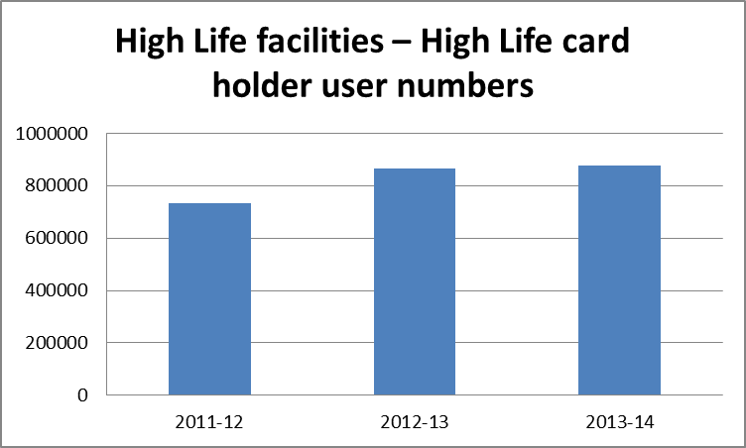

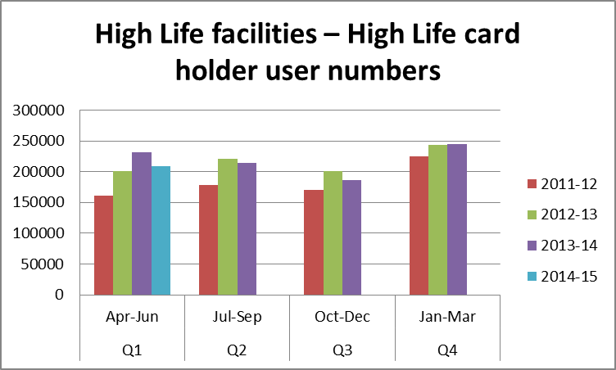

Use of Leisure Faciltiies by High Life members rose from 865,892 in 2012/13 to 875,837 in 2013/14. While the last quarter this year shows a drop of 32,678 uses compared with the same quarter in 2013/14, High Life memberships in June 2014 were 11,134, the highest they have ever been and 681 more than they were in the same month last year.

