HIGH LIFE HIGHLAND  REPORT TO BOARD OF DIRECTORS  28 AUGUST 2024 | AGENDA ITEM  REPORT No HLH / /24

TRAINING UPDATE - Report by Chief Executive

Summary

The report provides a progress update on the requirements and development of training for High Life Highland employees. Information about the recent work which has taken place, with proposed next steps is provided in this report.

It is recommended that Directors:

- note the progress made to date; and
- comment on the update.

1. | Business Plan Contribution
1.1 | High Life Highland’s (HLH) purpose is Making Life Better. The HLH Business Plan contains eleven Business Outcomes which support the delivery of this purpose, and this report supports the following highlighted outcomes from the Business Plan:  - Seek to continuously improve standards of health and safety.  - Commit to the Scottish Government’s zero carbon targets and maintain the highest standards in environmental compliance.  - Use research and market analysis to develop and improve services to meet customer needs.  - Increase employee satisfaction, engagement and development to improve staff recruitment and retention.  - Improve the financial sustainability of the company.  - Value and strengthen the relationship with THC.  - Develop and deliver the HLH Corporate Programme and seek to attract capital investment.  - Use research and market analysis to develop and deliver proactive marketing and promotion of HLH and its services.  - Initiate and implement an ICT digital transformation strategy across the charity.  - Develop and strengthen relationships with customers, key stakeholders and partners.  - Deliver targeted programmes which support and enhance the physical and mental health and wellbeing of the population, and which contribute to the prevention agenda.
2. | Background
2.1 | In light of the recent staff survey, the HLH Board discussed workforce training needs and officers were tasked with reviewing training needs and bringing a report back to the Board.
2.3 | Following discussion at the Board the topic of training was raised and discussed at a full management team meeting in October 2023 and it was agreed that a project team would be formed to take this work forward. The project team was formed in January 2024 including the Heads of HR, Estates and Environment, Governance and Scrutiny, Digital and Technology, Health and Wellbeing and the Activities Development Officer.
3. | Work of the project team
3.1 | The project team sought to understand the current training available along with databases and other tools used to track participation and compliance. This included a review of existing data bases and key training providers.
3.2 | A mapping exercise was also undertaken to map any mandatory and recommended courses with the training available from current providers. This mapping exercise demonstrated that a substantial number of mandatory and recommended training courses are available to HLH from The Highland Council’s (THC) online training platform, which is accessible to all HLH employees who have an HLH email address.
3.3 | Discussion with colleagues in THC’s Learning and Development Team, regarding HLH’s current and ongoing access to the Council’s online training, has been very positive. Discussions have included the potential and implications regarding possibilities for collaborating on the design and availability of additional/bespoke training to meet HLH training needs, using the council platform.
4. | Establishing need
4.1 | The full management team were consulted, via survey and a further discussion at a team meeting in April 2024, to understand the mandatory and other training needs in each service. The consultation sought views from managers on corporate and generic training needs, consideration was also given to any training needs that are specific to individual services, roles and locations.
4.2 | Feedback from the consultation highlighted that a strong majority of managers feel that there is sufficient training available for their service to operate safely. In the survey a total of thirty one responses were given, two responses stated that they did not think there was sufficient training for their service to operate safely and three responses said they “maybe” had sufficient training. When reviewed further the examples given by the five responses noted above included: as a result of budget constraints first aid courses cannot take place as regularly as preferred (noting the service is safe but there is a preference for more regular training) and a sense that there is insufficient training on using the financial and other systems as well as access to human resources training.
4.3 | The survey highlighted that priority training needs within teams included induction and the use of systems and processes.
4.4 | In the survey managers were asked if they thought their service would benefit from any management training. The responses were as follows:  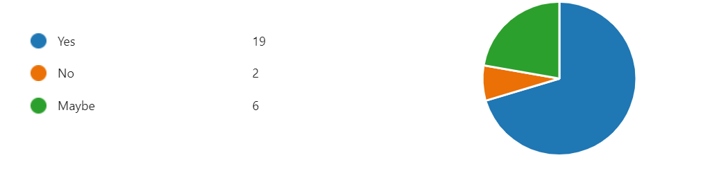
4.5 | Managers were asked if any of the following management training would be beneficial in their service – the responses are shown below:  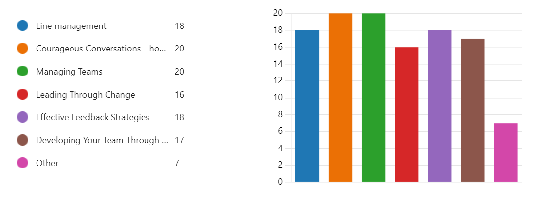
5. | Management training
5.1 | All HLH colleagues with line management responsibility, regardless of grade/level of experience, have been asked to complete management training, as outline in section 4.5 above. This training is delivered as short courses online and is available to all line managers by accessing THCs online training platform and is able to be completed at a time which best suits each individual manager. A deadline of the next full management team meeting in October 2024 has been set for completion of the training.
5.2 | Feedback and further inputs and suggestions from the management team will be sought at the next management session in October 2024.
6. | Further steps
6.1 | The Head of Human Resources will be taking forward the workstream for training. Consideration will be given to the short-term potential for actioning the additional findings and recommendations from the consultation with managers as well as the longer-term implications for potential ongoing requirements in designing, delivering and evaluating training for employees to meet HLH priorities and support strategic programmes and initiatives.
6.2 | It is noted that THC is currently recruiting a Learning and Development Manager and HLH will seek to connect with them to grow the opportunities for collaboration for the benefit of HLH colleagues.
6.3 | The work to date has been very much on the basis of what can be achieved within existing resources. As the work is further developed consideration will be given as to the requirement for an internal training resource. As training is embedded into the organisation opportunities which might be available through the relationships with HIE and UHI will also be explored.
7. | Implications
7.1 | Resource Implications – there are no additional resource implications arising from this report.
7.2 | Legal Implications - there are no new legal implications arising from this report.
7.3 | Equality Implications – there are no new equality implications arising from this report.
7.4 | Risk Implications – there are no new risk implications arising from this report.

Recommendation

It is recommended that Directors:

- note the progress made to date; and
- comment on the update.

Designation: Chief Executive

Date: 28 August 2024

Author: Lynn Bauermeister, Head of Health and Wellbeing

