|  |  |
| --- | --- |
| **HIGH LIFE HIGHLAND**  **REPORT TO BOARD OF DIRECTORS**  **11 December 2024** | AGENDA ITEM 13 REPORT No HLH/32/24 |

###### HR UPDATE – Report by Chief Executive

**Recommendation**

The purpose of this report is to update Directors on the charity’s HR related matters. It is recommended Directors:

1. note the HR matters for Q2 (Jul-Sep 2024);
2. approve for publication the Gender Pay Gap Report for 2023/24 in **Appendix C**; and
3. approve the Substance Misuse Policy in **Appendix D.**

|  |  |
| --- | --- |
| **1.** | **Business Plan Contribution** |
| 1.1 | High Life Highland’s (HLH) purpose is Making Life Better. The HLH Business Plan contains eleven Business Outcomes which support the delivery of this purpose, and this report supports the following highlighted outcomes from the Business Plan:   1. Seek to continuously improve standards of health and safety. 2. Commit to the Scottish Government’s zero carbon targets and maintain the highest standards in environmental compliance. 3. Use research and market analysis to develop and improve services to meet customer needs. 4. **Increase employee satisfaction, engagement and development to improve staff recruitment and retention.** 5. Improve the financial sustainability of the company. 6. Value and strengthen the relationship with THC. 7. Develop and deliver the HLH Corporate Programme and seek to attract capital investment. 8. Use research and market analysis to develop and deliver proactive marketing and promotion of HLH and its services. 9. Initiate and implement an ICT digital transformation strategy across the charity. 10. Develop and strengthen relationships with customers, key stakeholders and partners. 11. Deliver targeted programmes which support and enhance the physical and mental health and wellbeing of the population and which contribute to the prevention agenda. |

|  |  |
| --- | --- |
| **2.** | **Background** |
| 2.1 | During discussion at previous HLH Board meetings the question of the need for a human resources (HR) committee was raised and this was discussed at the Finance and Audit Committee meeting held on 11 November 2024. At the meeting:  “the general consensus was that responsibility for HR should remain with the main Board given that the charity’s services were delivered through its staff and the importance of leadership over simply considering staff as a resource |

|  |
| --- |
| or cost. It was recognised however that there needed to be greater clarity about what was reported and the key issues the Board needed to focus on with the potential benefits of a dashboard style HR report discussed.” |
| 2.2 The Finance and Audit Committee: “**AGREED** that the Senior Leadership Team |

conduct a review around the best way of reporting HR matters to the Board, in consultation with those Directors on the Service Delivery Contract group.”

* 1. Pending discussion with the Service Delivery Contract group, this report will be developed towards a dashboard style of reporting over the coming Board meetings and the improvements needed to the HR database to facilitate that are underway. This report provides information in addition to what has previously been reported, including the beginnings of trend information to support greater analysis of it, and summarises the HR matters for Q2 2024/25.
  2. Having carried out an initial review of information provided to the Board the following gaps were identified:
     + absence trend information;
     + staffing establishment trend information;
     + casework trends;
     + ACAS early conciliation claims.

###### Staffing establishment

* 1. Changes to the charity’s staffing establishment = +4.49FTE (**Appendix A**)
     + Quarter 2 (2024/25) establishment = 854.13 FTE
     + Quarter 1 (2024/25) establishment = 849.64 FTE
  2. Staffing establishment trend information has been provided as additional information and will be continued for future reporting.

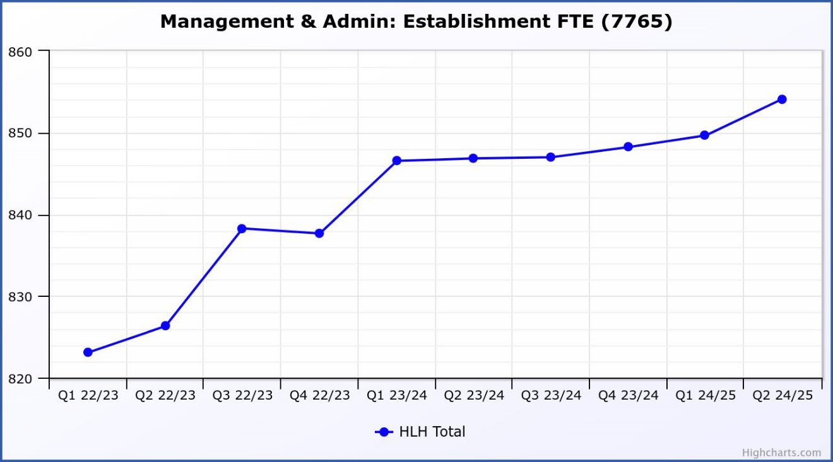

|  |  |
| --- | --- |
| 3.3 | The slight upward trend is primarily due to a temporary restructure within the Leisure management and highlife team, creation of an additional admin post for libraries, because of the loss of a shared resource as part of TUPE and the creation of an HR & Training post for the Castle Experience. Details can be found at Appendix A. The Adult Learning and Youth Work Staff who transferred to THC on 1 December will be recorded at the March HLH Board meeting. The Inverness Castle Experience staffing will be added from next financial year. |
| **4.** | **Staff turnover** |
| 4.1 | The number of resignations as a percentage of posts (number in brackets denotes the number of individual resignations) during the quarter was:  - July = 1.0% (10)  - Aug = 1.5% (15)  - Sept = 1.8% (18) |
| 4.2 | Staff turnover trend information has been provided as additional information and will be continued for future reporting. (This will be discontinued from future performance reports which will be amended as a result of the five year strategy).  A graph with blue lines and numbers  Description automatically generated  This graph shows resignations as a percentage of the number of posts (1% equates to 10 staff). |
| **5.** | **Attendance management** |
| 5.1 | Attendance management **(Appendix B)** has been RAG rated as amber in the performance report with further detail as follows:   * Short-term absence (<10 consecutive working days) = -0.25 * Long-term absence (>10 consecutive working days) = -0.40 * Long-term absences carried into Q2 = 16 individuals * Average days sick per FTE employee = 3.07 days |
| 5.2 | Staff turnover trend information has been provided as additional information and will be continued for future reporting. The following three graphs show: |

* + - overall **attendance** rate;
    - number of long-term **absences**; and
    - number of short-term **absences**.

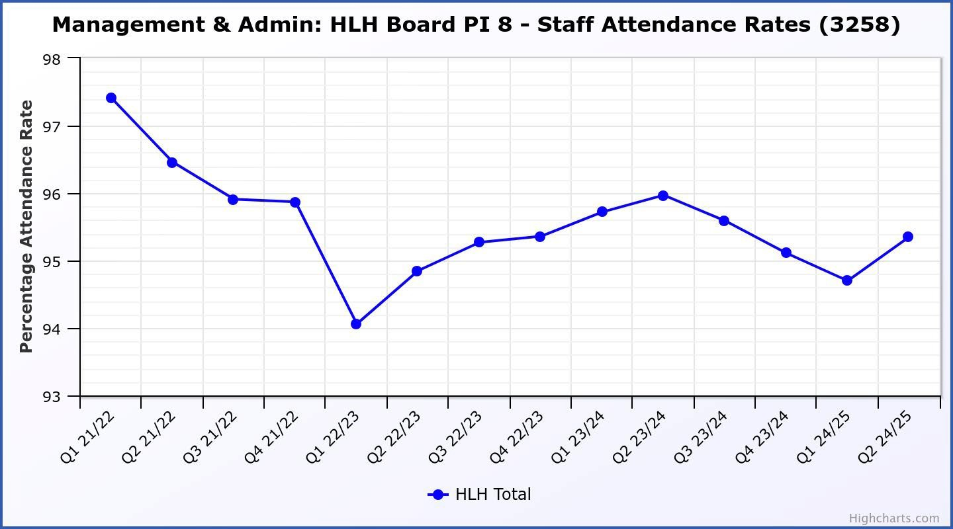

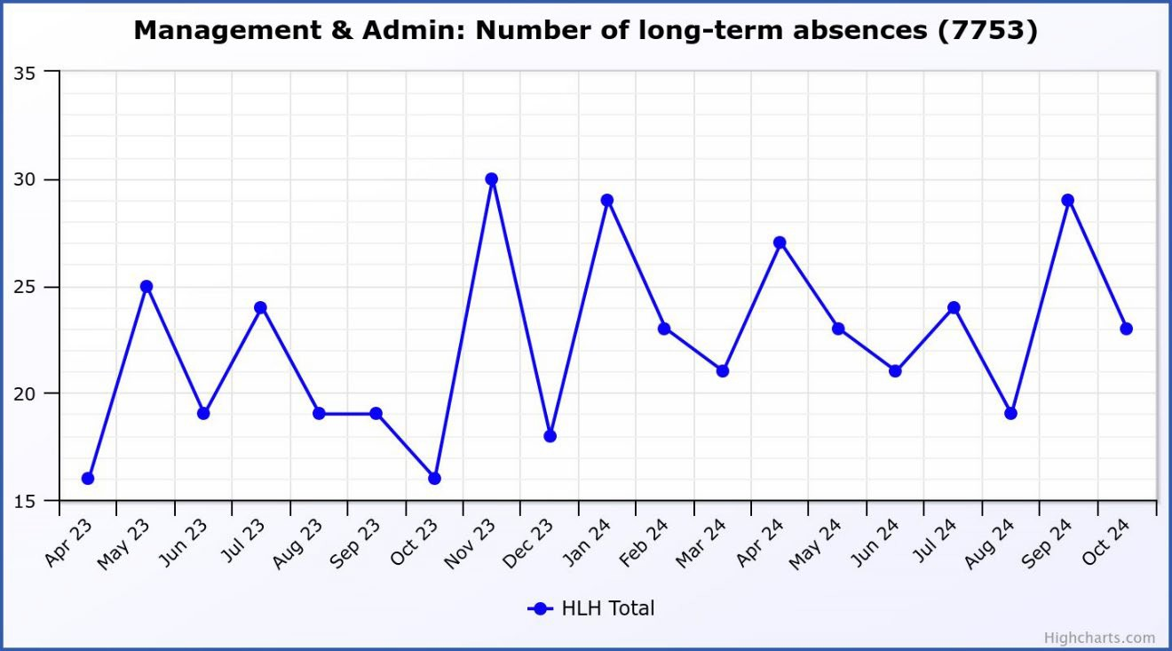

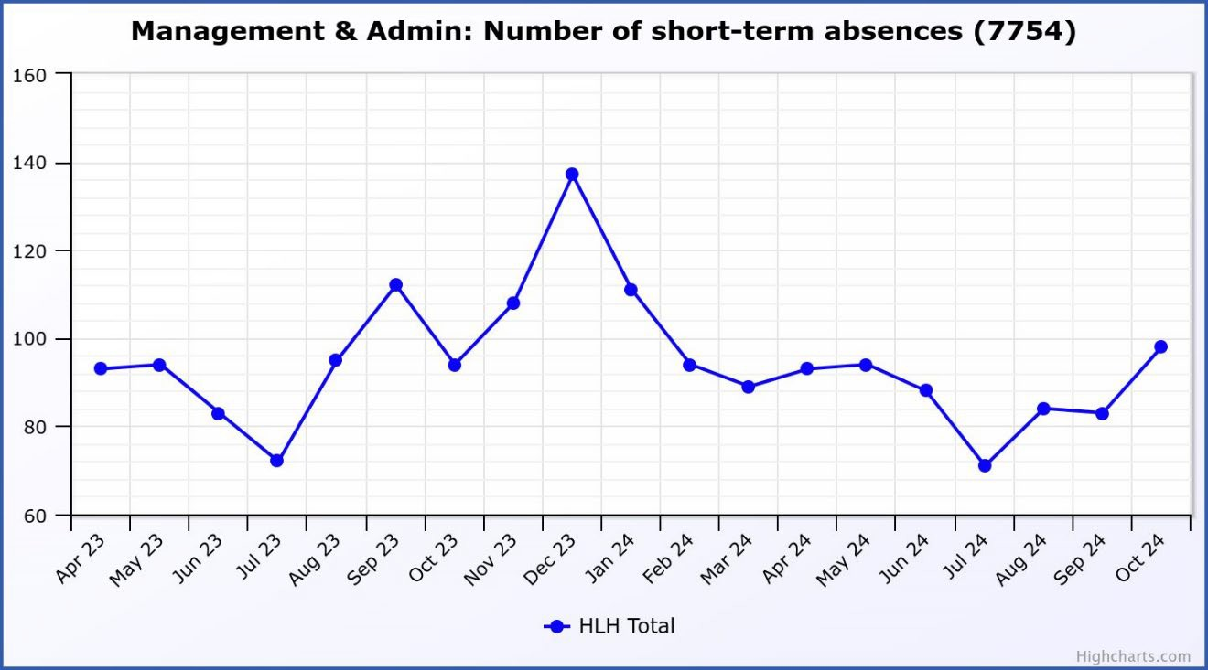

* 1. The HR Team continues to support service managers in the absence management of employees who are off sick on a long-term basis, using OH referrals, Wellness Recovery Action Plans and Counselling Services to expedite a quicker return to work, where possible.
  2. Throughout Q2, HR continued to proactively engage with the services in managing and resolving some of the more challenging cases, with employees either having now returned to work or left the organisation within Q2. These positive outcomes are in the data shown above and whilst there were 40 employees off work for periods exceeding 10 working days during the period, only 14 remained off at the start of Q3.

|  |  |
| --- | --- |
| 5.5 | Whilst the main focus over the past few months has been addressing the long- term absences, HR recognises the importance of also monitoring and managing frequent short-term absences, which can, at times, be far more disruptive to the workplace than long term absences. Managers are encouraged to review all absences and address emerging patterns of absence at an early stage. |
| **6.** | **Case Work** |
| 6.1 | Case work (use of formal processes and ACAS claims) has previously been reported by exception, so the information provided in this section is new. The following two graphs show the number of cases where disciplinary and then internal resolution (grievance) procedures have been used. The final two graphs in this section tracks the ACAS early conciliation claims and tribunal claims. |

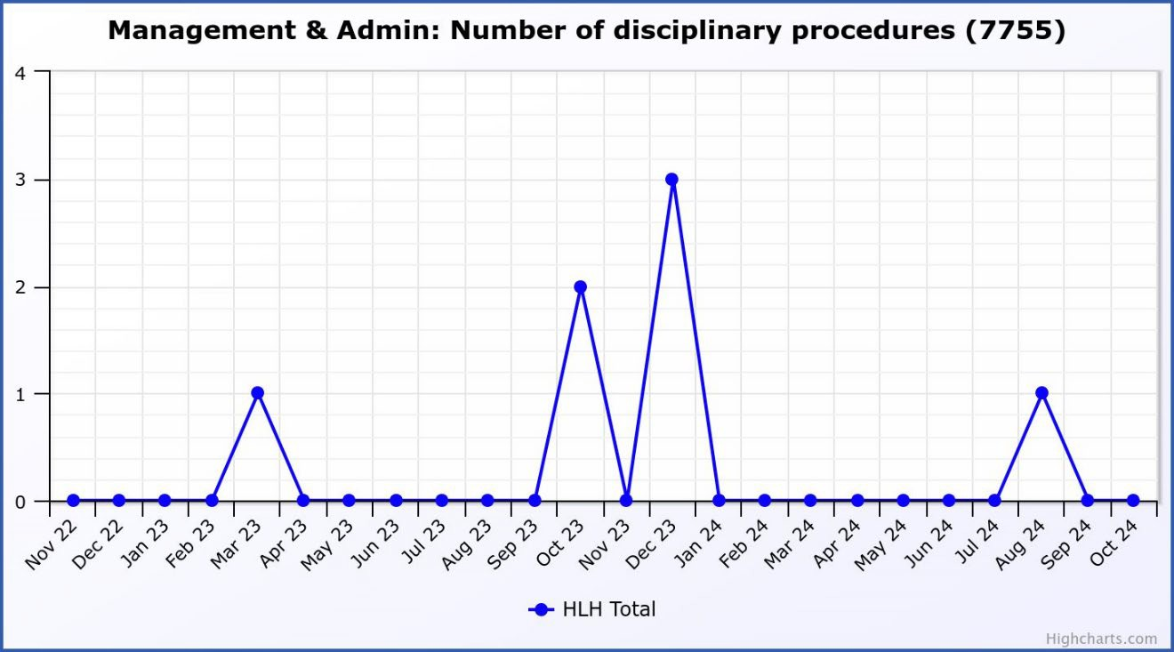

Thre was one disciplinary investigation carried out during quarter two.

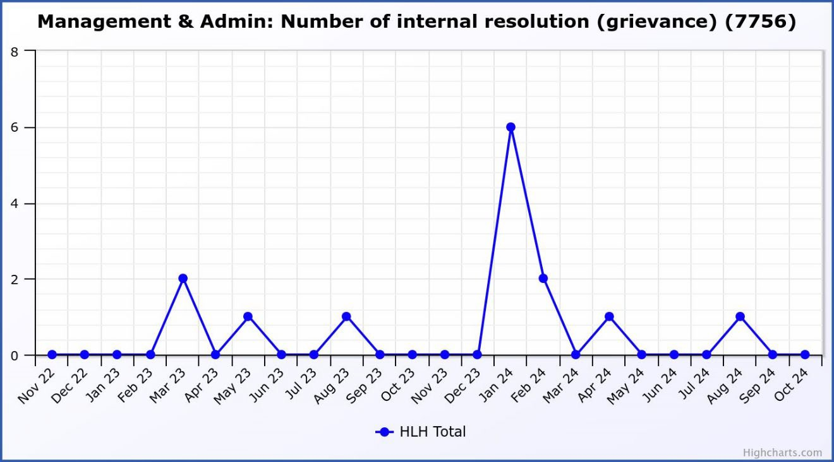6.2

There was one internal resolution in quarter two which was resolved.

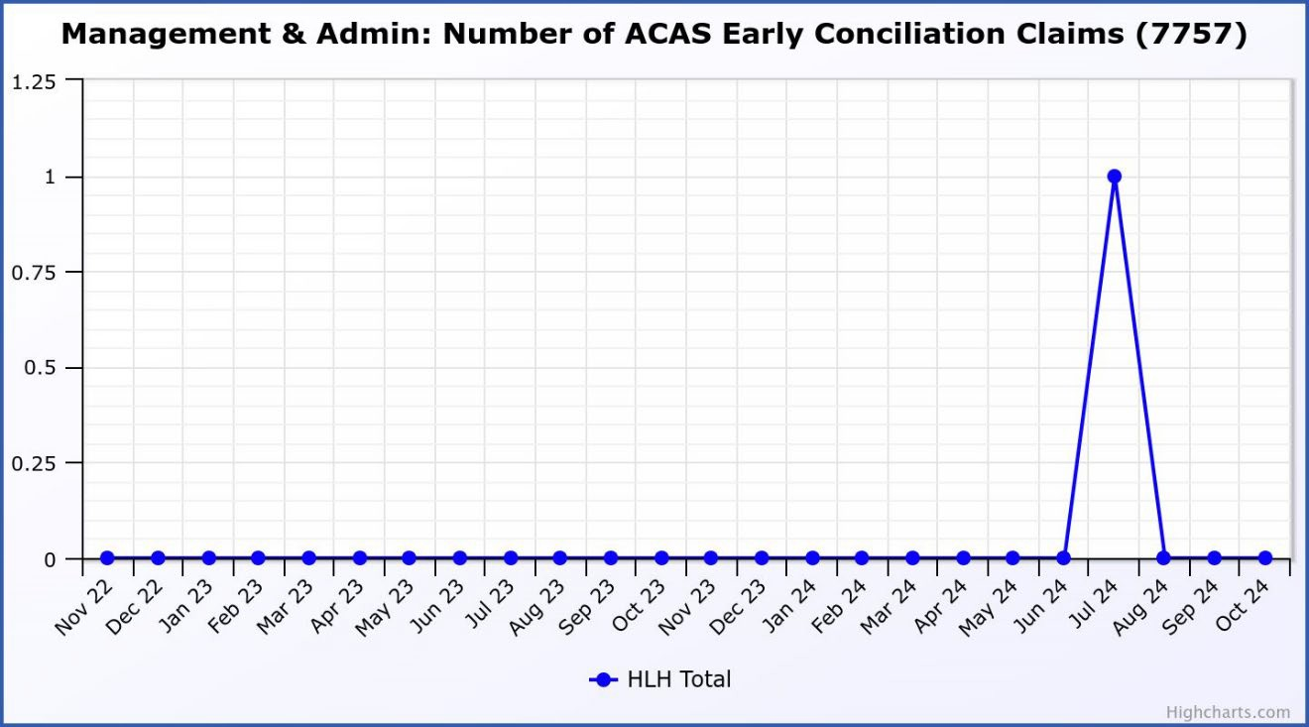6.3

There was one early conciliation claim in Q2. The enquiry was received from ACAS two days before the statutory deadline and no formal claim has been received to date.

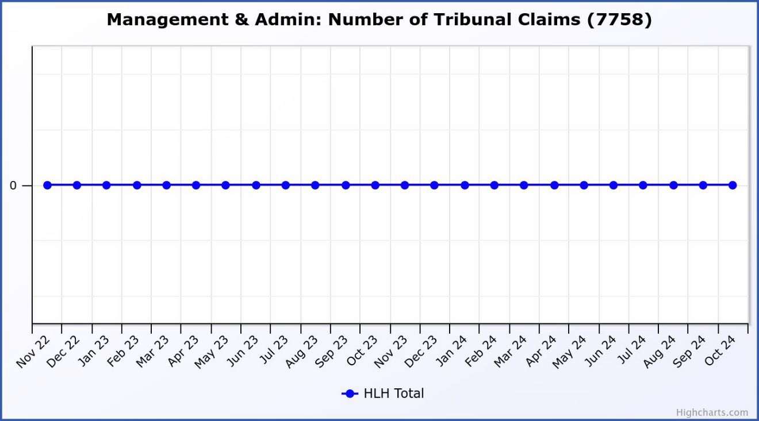6.4

There have been no tribunal claims over the past three years.

###### Gender Pay Gap 2023/24

* 1. Under The Equality Act 2010 (Gender Pay Gap Information) Regulations 2017 it is a legal requirement for organisations with 250 or more employees to publish a gender pay gap report by April each year.
  2. The gender pay gap is the difference between the average earnings of men and women, expressed relative to men’s earnings. Directors are asked to note that the gender pay gap **is not** the difference in salaries paid to male and female staff, all HLH staff (regardless of gender) are paid on the same salary scales.

|  |  |
| --- | --- |
| 7.3 | Employers must publish their [gender pay gap data and a written statement](https://www.gov.uk/guidance/gender-pay-gap-reporting-what-employers-must-publish) on their public website and report their data to government online. |
| 7.4 | The data required is:   1. mean (average) gender pay gap in hourly pay; 2. median (midpoint) gender pay gap in hourly pay; 3. mean bonus gender pay gap; 4. median bonus gender pay gap; 5. proportion of males and females receiving a bonus payment; and 6. proportion of males and females in each pay quartile. |
| 7.5 | HLH’s detailed results are provided in the draft Gender Pay Gap Report at  **Appendix C.** |
| 7.6 | The table below provides a comparison of the Gender Pay Gap results from 2021/22, 2022/23 & 2023/24:  **Difference between male and female hourly fixed pay Mean (average) Pay Gap Median (midpoint) Pay Gap**  **2021/22** 9.8% 15.7%  **2022/23** 9.9% 17.0%  **2023/24** 9.4% 14.8% |
| 7.7 | There has been no significant change in the male to female ratio (1:2) over the past year and a small decrease of 0.5% to the mean pay gap. However there has also been more significant decrease in the median pay gap of 2.2% in 2023/24. This is because of there being a slight decrease in the proportion of females to males in the lowest paid posts with an increase in females within the second lowest quartile, resulting in a reduced gap between female and male median hourly rates. In 2022/23 the gap was £2.52 per hour whereas in 2023/24 the gap was £2.03. |
| 7.8 | In addition, the pay award and revised pay modelling structure implemented in 2023/24 saw proportionately higher levels of pay increases in the lowest paid workers within Quartiles 1 & 2 of the GPG report which have a higher proportion of female workers than Quartiles 3 & 4. |
| 7.9 | Following discussion at the HLH Board last year steps have been taken to promote the employment policies which HLH has in place and this is provided on the recruitment page on the HLH web site and is provided in the application pack for all posts and can be seen at this link: [HLH-Staff-Benefits.pdf](https://www.highlifehighland.org/wp-content/uploads/2024/07/HLH-Staff-Benefits.pdf) |
| **8.** | **Industrial Relations** |
| 8.1 | The charity recognises and engages with the following unions:   * EIS * GMB * UNISON |

|  |  |
| --- | --- |
|  | * Unite the Union |
| 8.2 | Ongoing communication and consultation with the above unions is undertaken through the Joint Consultation Forum (JCF) which meets quarterly. |
| 8.3 | When the JCF met on 19 September 2024 the following items were discussed:   * Attendance Management * AYS TUPE * Substance Misuse Policy * HLH Budget Update |
| **9.** | **Substance Misuse Policy** |
| 9.1 | Further to a report to HLH’s Health and Safety and Environmental Compliance Committee dated 22 May 2024, it was agreed that:   1. HLH’s Substance Misuse Policy and Substance Misuse Procedures be reviewed in line with guidance by the Chartered Institute of Personnel and Development (CIPD) to ensure best practice; and 2. should national advice change (e.g. the Health and Safety Executive guidance on the safe operation of swimming pools) that this policy area be reviewed in the light of that. |
| 9.2 | Attached at **Appendix D** is HLH’s Substance Misuse Policy and Procedures with updates highlighted (in red). |
| 9.3 | These amendments have been discussed and agreed with HLH’s Trade Union representatives. |
| **10.** | **Implications** |
| 10.1 | Resource Implications – there are no new resource implications arising from this report. |
| 10.2 | Legal Implications – there are no new legal implications arising from this report. |
| 10.3 | Equality Implications – there are no new equality implications arising from this report. |
| 10.4 | Risk Implications – there are no new risk implications arising from this report. |

**Recommendation**

It is recommended Directors:

1. note the HR matters for Q2 (Jul-Sep 2024).
2. approve for publication the Gender Pay Gap Report for 2023/24 in **Appendix C**;
3. approve the Substance Misuse Policy in **Appendix D.**

Designation: Chief Executive Date: 27 November 2024

Authors: Morven MacLeod, Head of HR

###### Appendix A

**CHANGES TO STAFFING ESTABLISHMENT IN Q2 (Jul - Sept 2024)**

|  |  |  |
| --- | --- | --- |
| **Post Title** | **Location** | **FTE** |
| Admin Assistant 1 (Corporate BS) | HLH HQ, Inverness | 0.6 |
| Clerical Assistant 1 (Corporate BS) | HLH HQ, Inverness | -1.0 |
| Clerical Assistant 2 (Corporate BS) | HLH HQ, Inverness | 0.2 |
| Admin Assistant 1 (Libraries) | LSU, Inverness | 0.6 |
| HR & Training Officer (Castle) | Inverness | 1 |
| Bunkhouse Assistant | Glenfinnan | 0.29 |
| High Life Member Associate (Temp) | Inverness | 1 |
| Leisure Assistant | Lochbroom Leisure Centre | -0.09 |
| Leisure Assistant | ECCF | -0.06 |
| Assistant Manager (Temp) | Invergordon/Alness | 0.4 |
| Area Facilities Manager (Temp) | Various | 1 |
| Tutor Coach | Various | 0.55 |
|  |  | **4.49** |

Table 1

###### Appendix B Attendance Management Tables

|  |  |  |  |  |
| --- | --- | --- | --- | --- |
| **SHORT-TERM ABSENCE RATES** | | | | |
|  | **Quarter 1 (Apr–Jun)**  **%** | **Quarter 2 (Jul–Sep)**  **%** | **Quarter 3 (Oct–Dec)**  **%** | **Quarter 4 (Jan–Mar)**  **%** |
| **2022/23** | 2.07 | 1.63 | 1.35 | 1.52 |
| **2023/24** | 1.49 | 1.29 | 1.47 | 1.18 |
| **2024/25** | 1.39 | 1.14 |  |  |

Table 2

|  |  |  |  |  |
| --- | --- | --- | --- | --- |
| **LONG-TERM ABSENCE RATES** | | | | |
|  | **Quarter 1 (Apr–Jun)**  **%** | **Quarter 2 (Jul–Sep)**  **%** | **Quarter 3 (Oct–Dec)**  **%** | **Quarter 4 (Jan–Mar)**  **%** |
| **2022/23** | 3.76 | 3.52 | 3.38 | 3.12 |
| **2023/24** | 2.79 | 2.78 | 2.94 | 3.71 |
| **2024/25** | 3.91 | 3.51 |  |  |

Table 3

|  |  |  |  |  |
| --- | --- | --- | --- | --- |
| **AVERAGE SICKNESS ABSENCE DAYS PER EMPLOYEE** | | | | |
|  | **Quarter 1 (Apr–Jun)** | **Quarter 2 (Jul–Sep)** | **Quarter 3 (Oct–Dec)** | **Quarter 4 (Jan–Mar)** |
| **2022/23** | 3.61 | 3.40 | 2.89 | 2.83 |
| **2023/24** | 2.61 | 2.52 | 2.87 | 2.98 |
| **2024/25** | 3.34 | 3.07 |  |  |

Table 4

Community Leisure UK Member HR Survey 2023 Report

* Average (annual) sickness absence rate - 4.8%
* Average annual turnover - 17.7%

###### Appendix C

***Gender Pay Gap Report 2024***

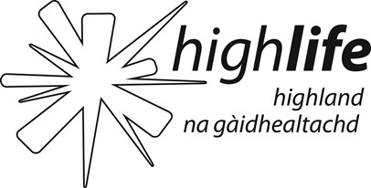

High Life Highland is a charity registered in Scotland, formed on the 1st October 2011 by The Highland Council to develop and promote opportunities in culture, learning, sport, leisure, health and wellbeing across 12 services throughout the whole of the Highlands, for both residents and visitors.

The Gender Pay Gap data supplied is correct for all employees in post with High Life Highland on 31 March 2024.

On that date there were 894 relevant and full-pay relevant employees, 319 (36%) males and 575 females (64%).

The figures set out below have been calculated using the standard calculations used in the Equality Act 2010 (Gender Pay Gap Information) Regulations 2017.

###### Pay and Bonus Gap

|  |  |  |
| --- | --- | --- |
| Difference between male and female | | |
|  | Mean | Median |
| Hourly fixed pay | 9.4% | 14.8% |
| Bonus paid | 0% | 0% |

* The table above shows High Life Highland’s mean and median gender pay gap based on hourly rates of pay.
* There were no bonuses paid to any staff in the year up to 31 March 2024.
* Of the 10630 employers reporting in 2023/24 the mean gender pay gap for all employees was 12.5% and the median gender pay gap 11.6%1
* High Life Highland’s mean pay gap of 9.4% is less than the national average by 3.1%.
* With a 14.8% median pay gap, High Life Highland is 3.2% above the national average for 2023/24.

1 [https://gender-pay-gap.service.gov.uk](https://gender-pay-gap.service.gov.uk/) Employers with 250 or more employees who have published their figures comparing men and women’s average pay across the organisation.

###### Pay Quartiles by Gender

|  |  |  |  |
| --- | --- | --- | --- |
| **Quartile** | **Males** | **Females** | **Description** |
| 1 | 37% | 63% | Includes all High Life Highland employees whose standard hourly rate places them in the 1st and lowest pay quartile. |
| 2 | 26% | 74% | Includes all High Life Highland employees whose standard hourly rate places them below the median pay in the 2nd pay quartile. |
| 3 | 35% | 65% | Includes all High Life Highland employees whose standard hourly rate places them above the median pay in the 3rd pay quartile. |
| 4 | 46% | 54% | Includes all High Life Highland employees whose standard hourly rate places them in the 4th and therefore highest pay quartile. |

* + The table above sets out the gender distribution at High Life Highland across four equally sized quartiles, each containing as follows Q1 224, Q2 223, Q3 223 and Q4 224 employees.
  + High Life Highland has an overall gender split of 36% male to 64% female. Quartile 2 shows the greatest disparity in gender distribution with a higher percentage of females compared to males in this quartile. However, Quartile 4 shows a more evenly distributed gender mix with 46% male to 54% female.

High Life Highland is committed to the promotion of equality of opportunity in its employment practices. It is committed to offering roles on flexible working patterns, with a range of options such as part-time working, alternative working hours, home working and shared parental leave.

The Charity’s Equal Opportunities policy states that it intends that no job applicant or employee shall receive less favourable treatment because of sex, marital or family status, age, ethnic origin, disability, race, colour, nationality, religion, belief, sexual orientation, gender reassignment or any other non-job related factor.

High Life Highland is also confident that males and females are paid the same rate for the job regardless of gender (or any other difference). Employees are remunerated according to set pay scales and terms and conditions which are negotiated nationally, through The Highland Council, by the Scottish Joint Council for Local Government Employees.

High Life Highland remains committed to monitoring and reducing the gap wherever possible, whilst also recognising that it has no direct control over the gender of applicants for particular job types or an individual’s career choices.

I confirm the data reported is accurate.

Steve Walsh Chief Executive

Appendix D

**Substance Misuse Policy**

V4

Reviewed - June 2022 Updated – September 2024

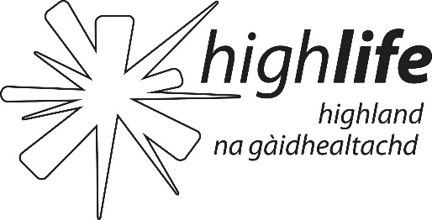

###### INTRODUCTION

* 1. High Life Highland’s purpose is Making Life Better and as such is committed to providing a safe, healthy and productive working environment. Alcohol and Drug misuse includes the use of illegal drugs, the misuse of prescribed drugs, new psychoactive substances (NPS or legal highs), non-prescribed preparations and the consumption of alcohol leading to impaired performance. The misuse of alcohol and drugs can lead to reduced efficiency, increased risk of accidents, increased absences, potential misconduct and criminality, and the loss of valuable employees.
  2. As part of the Charity's commitment to the health, safety and wellbeing of its staff, the purpose of this Policy is to help protect staff from the dangers of alcohol or drug misuse and to encourage those with a problem to seek help. In addition, the policy sets out procedures to ensure that alcohol and drug problems are dealt with sympathetically, fairly and consistently. The procedures describe support available and details of the circumstances in which disciplinary action will be taken.
  3. The Policy applies to all employees of HLH and contractors working for the organisation in all premises owned or occupied by the Charity.

1. **POLICY PRINCIPLES**
   1. Staff will not consume alcohol on HLH premises during their working day except by permission of the Director of Service e.g. Christmas party.
   2. Staff will not consume unprescribed drugs (except drugs which may be bought over the counter for minor ailments) during their working day, including main or rest breaks.
   3. Staff will not consume alcohol or take unprescribed drugs (except drugs which may be bought over the counter for minor ailments) at any time before reporting for duty when their use may impair work performance on duty.
   4. Staff should inform their manager of any prescribed drug that could have side effects and the impact on their ability to work safely.
   5. Possession of or dealing in unprescribed drugs at work will immediately be reported to the police.
   6. Staff have a duty to inform their manager if they suspect a colleague’s judgement is impaired due to substance misuse and could endanger life.



1. **PROCEDURES AND GUIDANCE FOR DEALING WITH SUBSTANCE MISUSE**

***Substance Misuse Procedures***

Approved SMT 14 November 2012

Updated September 2024

The aim of the Policy and Procedures is to set out High Life Highland’s (HLH) commitment to the Health, Safety and Wellbeing of its staff in respect of drug and alcohol use and to provide standard procedures for managing cases of substance misuse.

1. **DEALING WITH A SUBSTANCE DEPENDENCY**
   1. The following characteristics, especially in combinations, may indicate the presence of an alcohol, drugs or substance related problem. It should be noted that these symptoms could be caused by other factors:

* Absenteeism**:** Instances of unauthorised leave, frequent Friday and/or Monday absences, leaving work early, lateness (especially returning from lunch), excessive sickness absence, unusually high level of short term and intermittent absences with, or without, explanation;
* High accident level: at work, elsewhere, driving or at home;
* Work performance: difficulty in concentration, work requires increased effort, individual tasks take more time, problems with remembering instructions or own mistakes;
* Mood Swings: irritability, depression, and general confusion;
* Appearance: deterioration in physical appearance and or wellbeing;
* Unusual or uninhibited behaviour;
* Violence.
  1. **Self-referral and management referral**
     1. Employees who suspect or know that they have an alcohol or drug-related problem are encouraged to seek help and treatment voluntarily before the dependency has an adverse effect on their performance or safety. Where an individual member of staff seeks assistance in relation to such a problem, they will be invited to discuss their situation confidentially with their line manager or Human Resources who should refer them to Occupational Health.
     2. Where managers suspect, due to the deterioration in a member of staff's performance or behaviour that they might have a substance abuse problem, but no specific disciplinary offence is suspected, the employee will be invited to discuss their situation confidentially. They should be offered the same assistance as individuals voluntarily seeking help.
     3. Where a colleague suspects that another employee’s judgement is impaired as a result of substance misuse and could endanger life, they have a duty to inform their line manager immediately.
     4. Managers should approach such matters sensitively, taking care to avoid any assumption that substance dependency is the cause of poor performance or conduct. Ultimately, a diagnosis of substance dependency can only be made by qualified professionals and an appointment should be made with the Charity’s Occupational Health provider for assessment and diagnosis.
     5. Any request for assistance on a self-referral basis will normally be maintained as confidential between the employee, their choice of contact and HR, unless the individual concerned gives consent for information to be shared with another party.
     6. However, if staff are to be properly helped, some of the facts may have to be disclosed to others (for example, the employee's line manager, HR or OH). In such cases the individual will be asked to give specific consent before information is passed on. Refusal to give such consent may, in certain circumstances, amount to refusal to cooperate in taking treatment.
  2. **Treatment for a substance dependency**
     1. Once an employee has disclosed a substance dependency, he/she should be referred to OH using [Referral form](https://www.hlhinfo.com/userfiles/file/business_processes/Human%20Resources/HR27%20Occupational%20Health/HR27-F%20Occupational%20Health%20Forms/HR27-F01%20Occupational%20Health%20Referral%20Form%202012.docx) and be advised to seek support and/or treatment from their General Practitioner.
     2. Reasonable paid time off will be allowed for treatment if required and, so long as treatment is being undertaken, job security will normally be protected in exactly the same way as for staff with other serious health problems. The employee will be considered to be on sick leave.
     3. The employee will be entitled to return to or remain in the same job unless there are justifiable reasons for not doing so e.g. loss of driving licence. In such cases, consideration will be given to finding alternative suitable employment
     4. All employees who return to work after a period of absence associated with substance abuse will undergo a return to work medical with OH.
     5. Should an employee's performance continue to be unsatisfactory following a recovery programme for substance abuse, referral to the agreed disciplinary procedures will normally be followed.
  3. **Interviewing a suspected ‘Problem drinker/Substance Misuser’**
     1. This is an informal attempt at seeking resolution and would not be applicable in dealing with formal disciplinary or performance management issues.
     2. The Manager’s aim is to help those who may have a difficulty or to rectify unsatisfactory work performance/conduct due to substance misuse, within the Charity’s Policy. In so doing referral to OH will be offered for diagnosis and the employee will be expected to accept the referral and state their commitment to co-operating in the rehabilitation programme. Refusal of the referral may lead to disciplinary proceedings.
     3. In order to help the discussion the following guidelines may be useful:
        + As appropriate, wait until the effects of perceived substance misuse have disappeared
        + Seek advice from OH or HR
        + Confirm that the meeting is confidential subject to line management and HR advice.
        + Keep the focus of the interview strictly on the issue of work performance and/or conduct.
        + Present the employee with documented facts of the poor work performance and/or conduct if applicable.
        + Seek an explanation from the employee without leading or making suggestions of problem drinking or substance misuse. Remember there may be other causes such as domestic difficulties or the side effects of prescribed medication.
        + Listen carefully to the explanation and probe gently if necessary.
        + Ensure that the employee is made aware of this Policy.
        + Provide information on support agencies (see section 11).
        + Do not jump to conclusions.
        + Do not try to be an addiction counsellor.
        + Do not moralise.
        + Do not become involved in verbal battles to ‘prove’ right or wrong, fairness or unfairness.
        + Do not take it personally if the employee refuses all offers of help and / or remains in denial and / or relapses.
     4. Managing a situation in which an employee is believed to have a dependency problem requires a great deal of tact, understanding and patience on the part of the manager. In so doing, the objective is the rehabilitation of the employee.

1. **IDENTIFICATION OF A SUBSTANCE DEPENDENCY AS A RESULT OF A BREACH OF RULES, AN ACCIDENT OR A DANGEROUS INCIDENT**
   1. Where an employee admits to having a substance dependency following an alleged breach of rules, an accident or a dangerous incident, the circumstances will be fully investigated.
   2. If, following an investigation, it is decided to take disciplinary action; the employee's admittance of a substance dependency (if directly related to the disciplinary offence) will be taken into account as an extenuating or mitigating circumstance in determining the action to be taken.
   3. In the case of a first offence, the [disciplinary procedure](https://www.hlhinfo.com/userfiles/file/business_processes/Human%20Resources/HR08%20Disciplinary%20Procedures/HR08-G%20Disciplinary%20Procedure%20Guidance/HR08-G01%20Disciplinary%20Procedure.doc) will normally proceed to a disciplinary hearing and a decision.
   4. However the decision or appropriate sanction will be suspended until the employee is referred to OH for assessment. In the case of an action or incident which is construed as gross misconduct, management has the discretion to waive this requirement and proceed with disciplinary action.
   5. The employee must agree to adhere to any recovery programme prescribed for them by OH or another relevant professional. Failure to adhere to a recovery programme will result in the sanction determined at the disciplinary hearing being implemented.
   6. If the Professional Adviser(s) conclude that there is not a dependency issue or that a recovery programme would not be appropriate then the disciplinary procedures will normally be recommenced and the sanction will be implemented.
   7. An admittance of substance dependency will not normally be accepted as an extenuating circumstance in a second or subsequent disciplinary case after an employee has been referred for treatment.
   8. HLH does not at this time undertake random testing for drugs and alcohol but will keep best practice on the issue under review.
2. **POLICE INVOLVEMENT**
   1. Where there is concern that an employee may have acted outwith the law while at work, the Director of Service and Head of HR will be advised and a decision will be taken by the Director of Service on the appropriateness of police involvement.
   2. Internal disciplinary proceedings are separate and distinct from the actions of the Police and Procurator Fiscal Service.
   3. Criminal proceedings against an employee need not necessarily prevent internal disciplinary proceedings from commencing or continuing.
   4. Sometimes an employee’s actions outside of employment may lead to criminal proceedings/prosecution. Each case must be carefully considered. The Director of Service will be advised before any decision is taken to initiate formal disciplinary procedures. The fact that an employee is subject to criminal proceedings does not automatically mean the disciplinary process should be invoked.
   5. Staff must inform their manager if they are convicted of any criminal charge regarding the use or supply of drugs. It will be for the Director of Service or designated senior officer in liaison with HR to determine if any further action is required.
   6. Any information will be treated in the strictest confidence except in so far as it is necessary to inform other members of the Service senior management and/or HR.
   7. Drinking/Drug Misuse and Driving – The loss of a driving licence due to a conviction for driving while over the legal alcohol limit or under the influence of drugs can have repercussions on continued employment depending on the nature of the post. An individual who has to drive as part of their job may be dismissed, although consideration would first be given as to whether alternative methods of carrying out their role could be instigated.
3. **ONGOING MANAGEMENT**
   1. As stated in Section 2.3 an employee with a dependency problem will be given every assistance to overcome their dependency.
   2. The Manager (with advice from OH and HR) should set the individual reasonable objectives and review performance in line with these.
4. **REMOVAL OF POLICY SUPPORT**
   1. Whilst recognising that dependent substance abusers may merit consideration that may include treatment or rehabilitation, this policy does not allow for employees involved in an isolated incident of unsatisfactory conduct to avoid disciplinary action by claiming to have a substance abuse problem.
   2. Any claim to a substance dependency will require confirmation from OH/appropriate professional. Similarly, the policy offers no protection in cases which are in direct contravention of the law (for example, possession or supply of illegal drugs or drink-driving).
5. **PRESCRIBED MEDICATION**
   1. It is recognised that some employees are required to take prescribed or over the counter medication to manage ongoing health issues. Some medication may have side effects which could increase the risk of accidents particularly for staff responsible for the health and safety of other colleagues or customers. Employees must inform their manager of any prescribed or over the counter medication that might impact on their ability to work safely so that an appropriate risk assessment can be carried out. Managers should seek guidance from the OH as necessary.
6. **TRAINING AND DEVELOPMENT**
   1. HLH will provide training to support the implementation and management of alcohol, drugs and substance misuse problems.
   2. Training will be available to line managers and supervisors in order to develop ‘early recognition’ techniques for identifying employees misusing alcohol or drugs and in the use of effective interviewing skills so that employees can be dealt with promptly, tactfully and firmly.
7. **COMMUNICATION**

This policy will be communicated to all employees. HLH will strive to ensure that all employees, managers and supervisors are aware of their responsibilities under the Policy and receive training as appropriate to their role.

1. **MONITORING**
   1. Human Resources will monitor the number of alcohol /drug related matters that are referred to Occupational Health, and any disciplinary actions taken where alcohol and /or drugs are involved.
   2. All monitoring will be on an anonymous basis
2. **OTHER POLICIES AND PROCEDURES**
   1. This Policy will be supported by, and should be read in conjunction with the following policies and procedures:
      * [Disciplinary Procedure](https://www.hlhinfo.com/userfiles/file/business_processes/Human%20Resources/HR08%20Disciplinary%20Procedures/HR08-G%20Disciplinary%20Procedure%20Guidance/HR08-G01%20Disciplinary%20Procedure.doc)
      * [Absence and Attendance Management Policy](https://www.hlhinfo.com/userfiles/file/business_processes/Human%20Resources/HR01%20Absence%20and%20Attendance%20Management/HR01-P%20Absence%20and%20Attendance%20Management%20Policy/HR01-P01%20Absence%20and%20Attendance%20Management%20Policy.doc)
      * [Absence and Attendance Guidance](https://www.hlhinfo.com/userfiles/file/business_processes/Human%20Resources/HR01%20Absence%20and%20Attendance%20Management/HR01-G%20Absence%20and%20Attendance%20Management%20Guidance/HR01-G01%20Absence%20and%20Attendance%20Management%20Guidelines.doc)
3. **SUPPORT AGENCIES**

**Drinkline** – a government-funded free service. Can provide advice to the alcohol drinker or anybody concerned about the drinker. Has a database of local support and treatment services that can help the drinker.

Helpline: 0800 917 8282 Website: [www.drinkaware.co.uk](http://www.drinkaware.co.uk/)

**Talk to FRANK** – a government-funded free service, previously named the National Drugs Helpline. Can provide advice to the drug user or anybody concerned about the drug user. Has a database of local support and treatment services that can help the drug user. The focus of the helpline is for young people and concerned parents, but will also assist adult drug users.

Helpline: 0800 77 66 00 Website: [www.talktofrank.com](http://www.talktofrank.com/)

The website provides detailed information on drugs that the non-specialist can understand. **Alcoholics Anonymous** – the largest self-help group for people who acknowledge they cannot handle alcohol, and want a new way of life without it. Services are free

Helpline: 0845 769 7555 Website: [www.alcoholics-anonymous.org.uk](http://www.alcoholics-anonymous.org.uk/)

The comprehensive website explains the philosophy of AA, what to expect, and local groups. **Alcohol Focus Scotland** - is Scotland's national charity working to reduce the harm caused by alcohol

Website- [www.alcohol-focus-scotland.org.uk](http://www.alcohol-focus-scotland.org.uk/)

**Scottish Drug Forum (SDF)** - The SDF can provide advice on drug agencies and local drug services in Scotland and details of your nearest drug team.

Helpline: 0141 221 1175 Website: [www.sdf.org.uk](http://www.sdf.org.uk/)

**Annex A**

**GENERAL FACTS ABOUT SUBSTANCE MISUSE**

**Adverse Effects of Alcohol**

The consumption of alcohol in moderation is acceptable in a social context. However, its potential to impair performance and behaviour must not be ignored, particularly in the workplace. Alcohol is absorbed rapidly from the stomach into the bloodstream resulting in slowing down of reaction times, co-ordination and judgement. It has been estimated that 20% of all work accidents are related to alcohol. Regular excessive consumption of alcohol is likely to lead to serious medical problems. These include the following:

* Raised blood pressure
* Cirrhosis of the liver and/or hepatitis
* Stomach ulcers
* Cancers
* Psychological dependency and depression
* Sexual dysfunction
* Sudden death – alcohol poisoning, stroke

**Categories of Illegal Drugs**

‘The Misuse of Drugs Act 1971’ defines three categories according to their relative harmfulness when abused. Penalties for offences tend to be more severe the more harmful the drug class.

**Class A**: includes cocaine, crack cocaine, ecstasy, heroin, LSD magic mushrooms, methadone, methamphetamine (crystal meth).

**Class B**: includes amphetamines, barbiturates, cannabis, codeine, GHB, GBL, ketamine, methylphenidate (Ritalin), synthetic cannabinoids, synthetic cathinones (e.g. mephedrone, methoxetamine) **Class C**: includes anabolic steroids, benzodiazepines (diazepam), khat, nitrous oxide (laughing gas), piperazines (BZP).

**Medication and Other Substances**

Prescribed medication and some over-the-counter drugs such as anti-depressants, sleeping pills, stimulants or hay fever remedies can cause drowsiness and loss of concentration. These effects may be intensified if even small quantities of alcohol are also consumed. These side effects increase the risk of accidents particularly for staff operating machinery or working at heights. There is a risk of misuse of prescribed medication and some over-the-counter drugs, which may equally be covered by the terms of this policy.

**Effects of Solvent Abuse**

The effects of sniffing solvents are felt very rapidly because the chemicals are absorbed from the lungs directly into the bloodstream. To an observer the effects of sniffing may appear to be similar to drunkenness. To the user, the two are very different. They look similar because of the general intoxication, confusion and lack of co-ordination, but from the user’s perspective, solvents cause hallucinations, euphoria and perceptual distortions (which alcohol does not). Alcohol also has much longer lasting effects whereas solvents only act for a few minutes: users must repeat the process in order to stay intoxicated. Misuse/abuse of solvents at work is a disciplinary offence.